Read the PowerPoint slides and the handout.

Using the information contained in the PowerPoint slides complete the SWT Analysis of the following images. Please give as much detail as possible as your assessment will look very similar to these.



Symbolic

Written

Technical



Symbolic

Written

Technical



Symbolic

Written

Technical

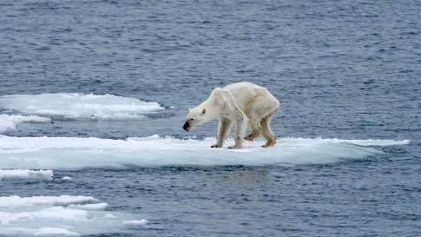

Symbolic

Written

Technical

